HINES DEVELOPMENT PROPOSAL & THE THOROUGHFARE

Even if Hines decides to pass on the opportunity for now, others will be pursuing it in the future. And the "Major Thoroughfare Plan" (MTP) will be pushed again someday, no matter how they get it paid for.

Now would be a good time to get some of the past, both in 1998 & 2006, commitments, made by the then sitting city officials and elected leaders, made permanent and as public as possible.

These thoughts were shared with me earlier:
"From what I’ve been told so far, we can’t stop the thoroughfare but we may be able to move it over some, into the drainage and going over the pipelines there off Wilderness Trails. And the best argument for keeping Castlewood closed off is the safety of our children in the neighborhood pool. We should also ask for a minimum 50’ set back, providing green space and require the new neighborhood to maintain it."

I too doubt that stopping any development of the Arndt or Exxon property is not something we can or should even try to do. Someone buys land and meets all of the requirements, more power to them. After all, 187 $1million dollar houses is a whole bunch of tax revenue. Property and sales taxes.

Other than that, I agree with everything that was stated as issues to deal with.

But there is more to consider:
- Does Friendswood really want the 528 to Pearland section of the road?
- The thoroughfare path.
- The financing of the project by The City, especially without independent proof that the Exxon land is not contaminated.
- Repeated breaking of commitments made by previous city leaders.

My thoughts...

1. The City of Friendswood should not issue bonds (create debt) in order to finance this project for any developer. Especially property that may hold contamination that disqualifies it as a suitable place to live.

We voted down issuing bonds to fund other infrastructure and the thoroughfare in the recent past. This public investment district, or PID, is just another way to create debt without having to let the public vote on it. Just need a public hearing and then it is up to City Council to approve it.

At the very least testing for contaminates should be done and made public on the old Exxon property. Especially if Friendswood municipal bonds might be issued to finance a project on it. It is our tax dollars at risk to back that debt. If a problem comes up before the bonds are paid off Friendswood is on the hook for that debt.

2. We should seek to have West Castlewood, at least the portion between Greenbrier and the dead-end just past Applewood removed as a designated connector street. Then have the dead-end remain in place. We should do this regardless of what happens with Hines. Connectors are supposed to be 80 feet wide. Castlewood is a narrow 60 foot ROW.

The proximity to our neighborhood pool and playground demand that this dead-end remain a dead-end. Just like the dead-end at Mossy Stone and Friendswood Lakes Blvd. No, Mossy Stone is not a collector. Nor should Castlewood be. At least the section within Wilderness Trails.

We, as most neighborhoods do, have enough issues with speeding and stop sign running teens, parents, and old people (like me.) We do not need more traffic. Especially when the high school day starts and ends or any events take place there. Football games in particular.

3. IF there must be a subdivision and a thoroughfare, then let's get the same buffer that the Friendswood Lakes Blvd. homes have. Except for a very few at 30 feet almost every home has at least a 50 foot buffer from the road.

4. Many still question the rationale of extending any road past what will be the retail development on the old Wischnewsky land that fronts 528. (See “Future Land Use Map”)

Going beyond 2351 into Pearland takes one into mostly light to medium industrial properties. There is "Pearland Regional Airport." Not really a destination. Beyond that there is a big land fill. Shortly after that Pearland Parkway turns north a goes to BW8.

Putting a 4 lane thoroughfare that connects I45 to this industrial / landfill section of Pearland is inviting lots of big loud, polluting, and dangerous commercial traffic. The League City side of this Major Thoroughfare Plan is all residential. As is the Friendswood portion from League City to 528.

Maybe we should table this FM 528 to Pearland section and see how The Grand Parkway works out?

We have volumes of communications, letters, news articles, old city council meeting minutes, maps, charts, etc. that show the history of this thoroughfare route controversy.

Bottom line is we have already had this discussion. Twice. Once in 1998. Again in 2006 when the “goof” that the then city manager claimed happened was done in error prompted the 2006 campaign of opposition. The path of the thoroughfare has not changed since then. At least on any published Friendswood Master Thoroughfare Plan that I can find.

Wilderness Trail Road and subdivision residents, among others, received promises and commitments that this thoroughfare would be built, if ever, on the other side of the Exxon property and away from Wilderness Trails subdivision.

We want the current staff and elected / appointed officials to uphold their predecessors’ commitments.

And yes, there is evidence after 2007 events took place that made it obvious that the currently published path was no longer viable. Yet city officials still have the 528 to Pearland path unchanged since 2004. At least it is still one of the two routes published in 2004. Even today that path remains the same on the most updated plan map dated 2018.

Does it seem like they did not want us to notice?

MAJOR THOROUGHFARE PLAN PUBLISHED REVISIONS:
1998 – OPPOSED BY PUBLIC
1998 – REVISED AFTER OPPOSITION
2004 – TWO ROUTES. ONE AS ILLUSTRATED. THE OTHER SAME AS POST OPPOSITION 1998
2018 – CURRENT PATH.

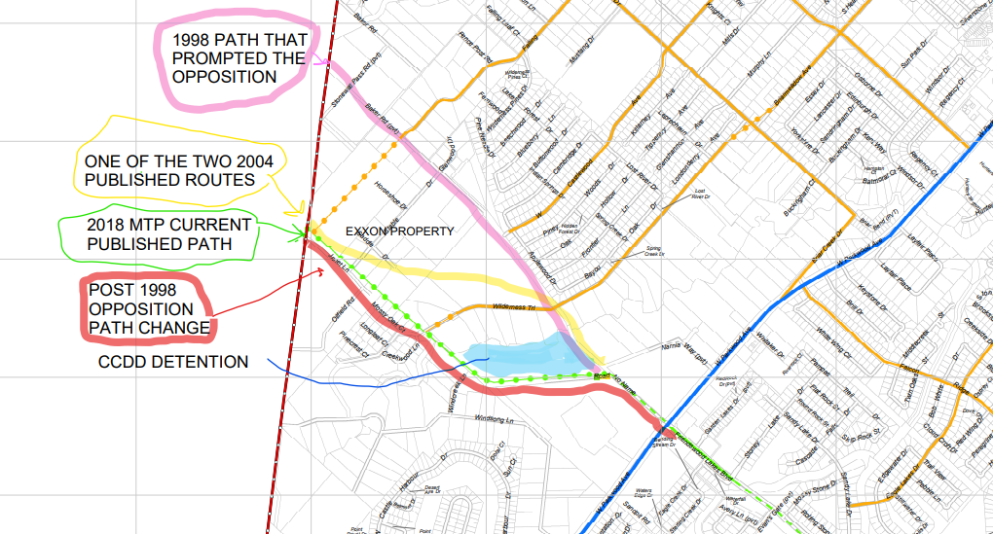
Here is what was distributed anonymously to several of the homes in Wilderness Trail. I am guessing it came from a nearby subdivision…
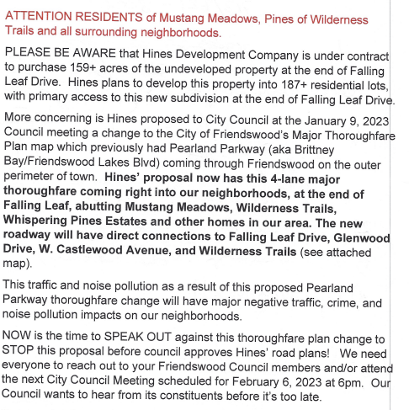
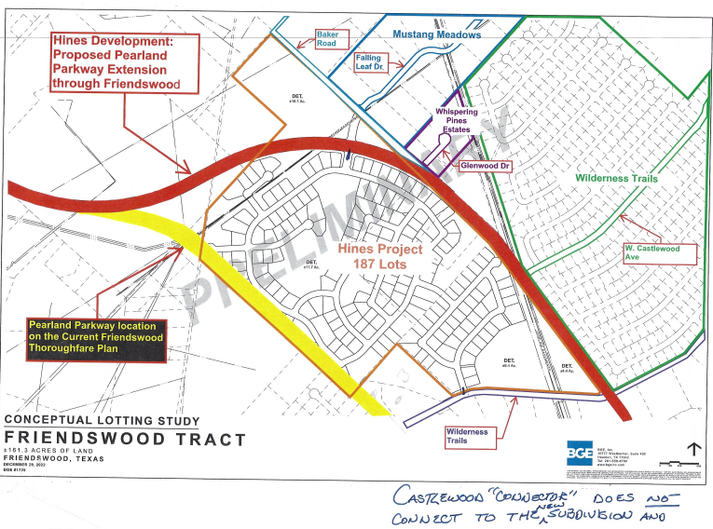
Friendswood Future Land Use Map
The “W” is the Wischnewsky acreage that will become a pretty good sized retail center. This may help bring the total picture into focus.
The SFR – E is zoned single family residence – estate. The “E” requires 2 acre home sites.
The zoning on the old Arndt property would need to be changed to just SFR.
